Programming 1 (P1): Building xv6, Part 2.

(I, **Zachary Doctrove**, completed this project by myself)

**Section 1: Changes Made to the xv6 directory.**

2.1 Adding a new user program: “spin.c”

Screenshot set #1: I created a new c project called “spin.c” in Visual Studio and I then put its file into the xv6 file directory on my Windows computer, so the xv6 OS can access the file.



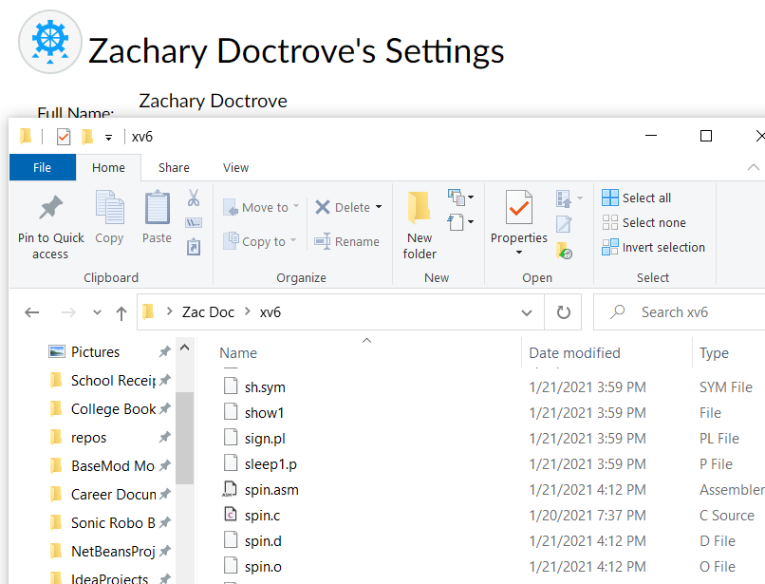

**“spin.c” is now available to xv6**:

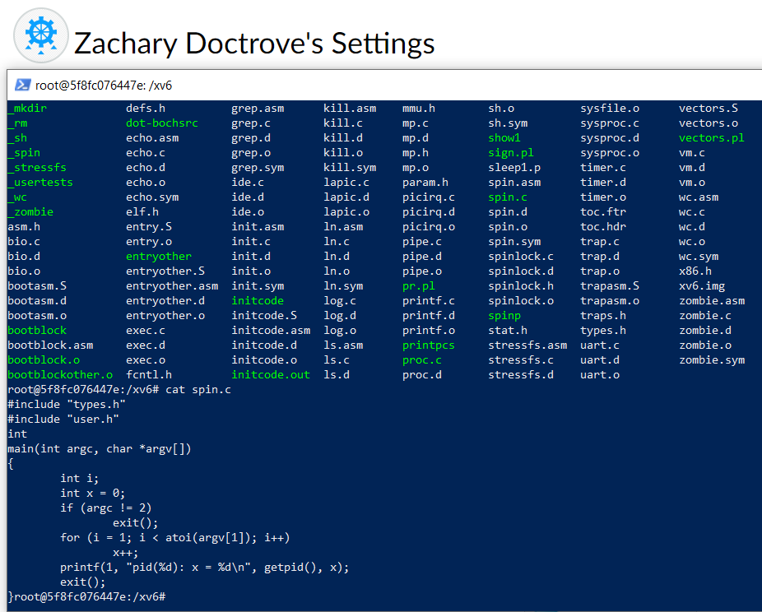

Screenshot #2: Modifying the area under “UPROGS” in the “Makefile” of xv6 to make “spin.c” fully operational.

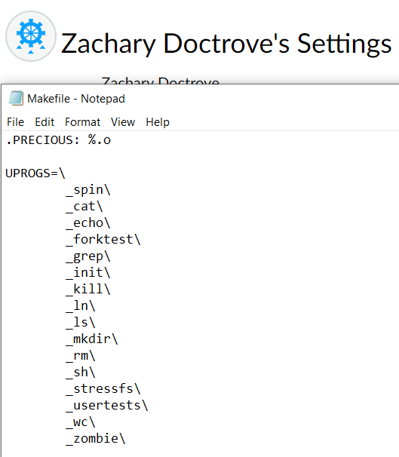

2.2 Modifying and accessing the Process Control Block (PCB)

Screenshot #3: Adding declarations of **int queuetype** and **int quantumsize** inside of proc.h, **under struct proc**

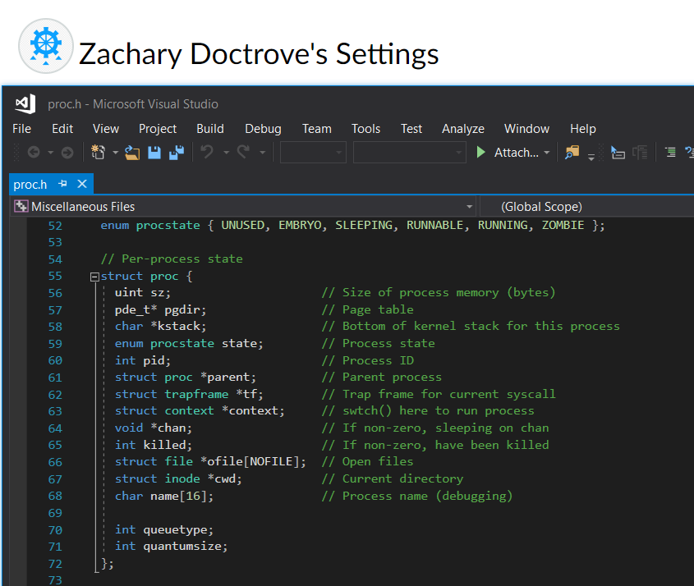

Screenshot set #4: Initializing the values **queuetype** and **quantumsize**, and then writing c code that prints out their values alongside a message about the process being run (Every time a process is run).

**Initialization under allocproc()**

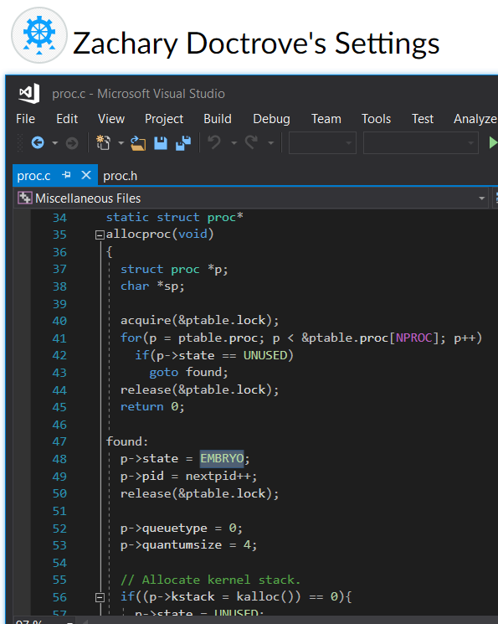

**“Print out” code under scheduler().**

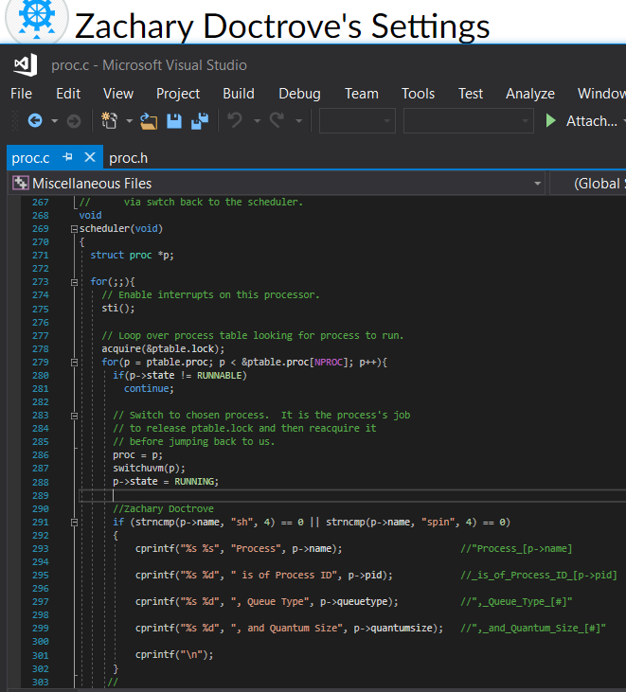

**Section 2: Testing results after rebuilding and rerunning xv6.**

Screenshot Set #5: The Result of the commands **“spin 100 &”**and **“$ spin 10000000 &; spin 10000000 &; spin 10000000 &;”**

**(Notice how the process #21 eventually gets its true name revealed as spin)**

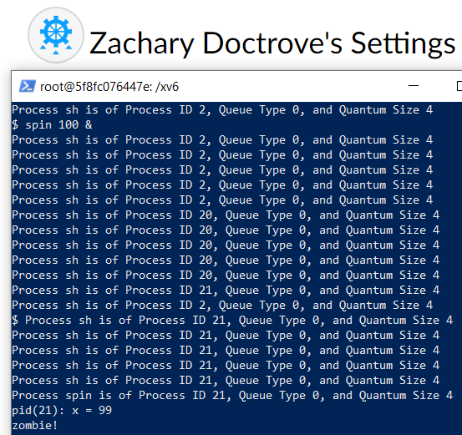



First Command 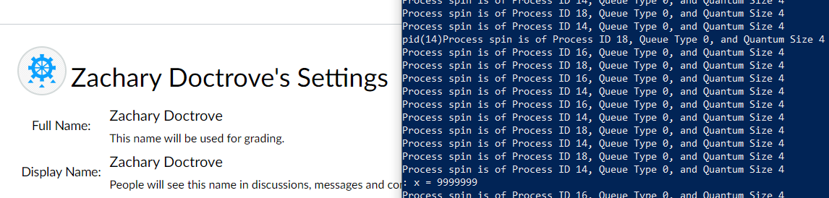



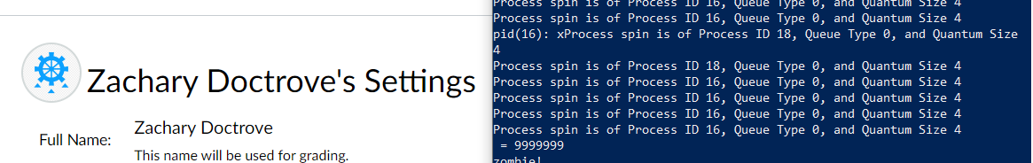Middle Command



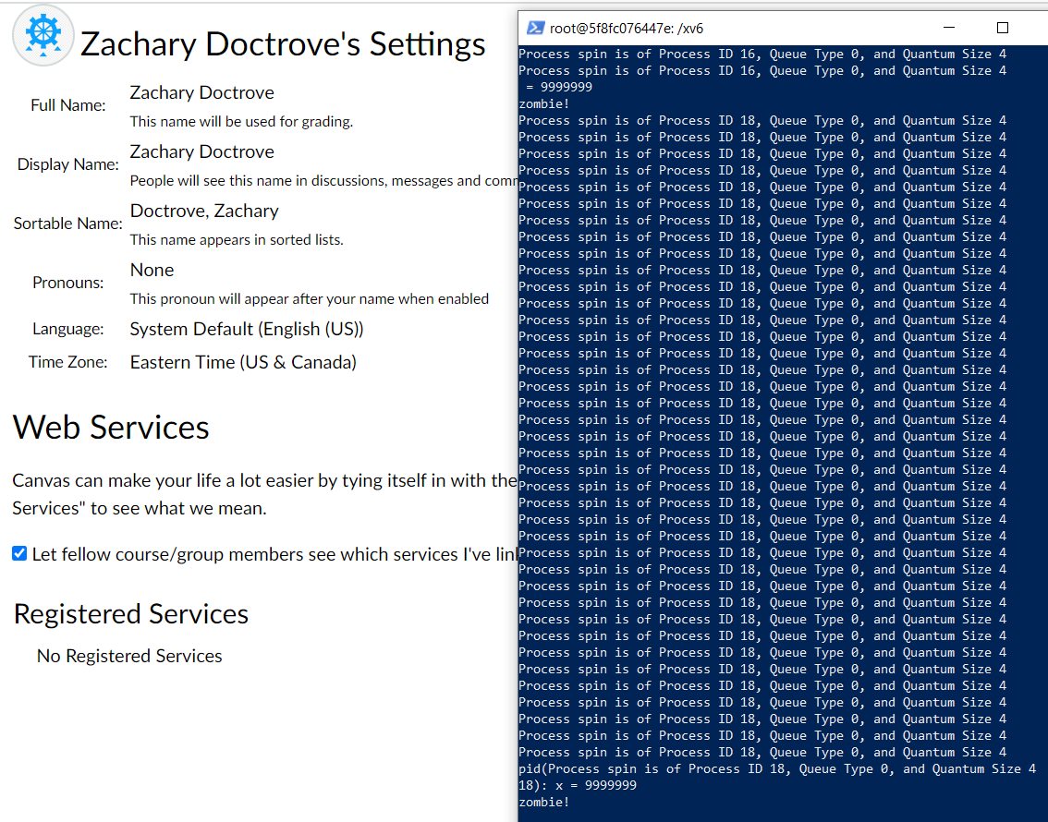Last Command

